Personal Assistant Ticket Guide

We offer Personal Assistant tickets for guests who require additional assistance during their visit, at no additional cost. Please see our step-by-step guide below:

## Step 1 - Deciding what tickets you need

When will you be attending?

* All Sessions Entry
  + If you wish to attend multiple sessions.
* Flexi Single Session Entry
  + If you are not sure what day and session you would like to attend, you can turn up on the day and session of your choice.
* Single Session Entry
  + A screenshot of a computer

    AI-generated content may be incorrect.If you know exactly what day and session you will be attending.

Ticket types:

* TASTE PASS - Entry to Taste of London
* TASTING TICKET - Entry to Taste of London plus 2 Signature Dish Vouchers
* TASTE VIP (2 Dish) - Fast Track entry to Taste of London, VIP access, plus 2 signature Dish Vouchers
* TASTE VIP (3 Dish) - Fast Track entry to Taste of London, VIP access, plus 2 Signature and 1 Exclusive Dish Vouchers

## Step 2 - Purchasing your Tickets

Everyone visiting Taste of London will require an admission ticket into the event, including Personal Assistants/Companions. Please add your Personal Assistant ticket alongside the number of tickets you require.

The Personal Assistant ticket tab can be found by scrolling below our other ticket types.

Personal Assistant tickets can only be purchased if there is an adult ticket holder on the booking.

Step 3 - Uploading your Documentation

Head to checkout where you will be asked to submit your supporting documentation.

Please upload this supporting documentation to be reviewed and accepted.

Examples of relevant documentation to support your Personal Assistant request include:

* Copy of DLA, PIP or Adult Disability Payment entitlement letter
* Evidence of registered severely sight
* impaired (blind)
* CredAbility Access Card (with +1 icon)
* Copy of Attendance Allowance letter
* Recognised Assistance Dog ID card
* A current and valid blue badge
* Any other relevant documentation

All documents provided must show your full name and be dated from no older than 2022.

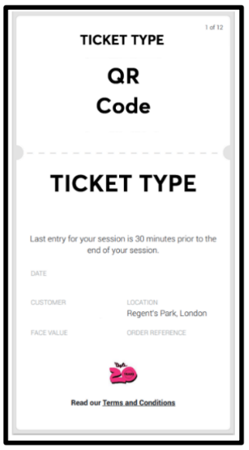

## Step 4 - Your Tickets

Your tickets will be issued via email with the following layout:

# Contact Details

For any ticketing queries, please contact See Tickets [HERE](https://supportcentre.seetickets.com/?Website=taste_of_london)

For additional information about accessibility at the event, please see the Accessibility page on our website

For any other queries about the event, please contact our customer service team [HERE](https://help.london.tastefestivals.com/hc/en-gb)

# Further Information

For those with Child and Teen tickets, Personal Assistant ticket shall also be provided if required, at no additional cost, but the child or teen must be accompanied by a paying adult ticket holder.

Please note, bookings are limited to 1 Personal Assistant ticket per adult ticket. If you require 2-1 support and therefore require additional Personal Assistant tickets, please contact See Tickets or the Taste of London Customer Service Team.

Everyone in your party will need an admission ticket prior to arriving at the event. Please do be sure to select your Personal Assistant ticket as well as your own if you require additional assistance whilst at the event.

The above scheme and facilities are for customers with permanent/long-term access requirements and are not for people with temporary impairments such as broken bones, healing wounds or people who are pregnant.

Personal Assistants attending through this scheme need to be 18 years old by the start of the event.

Personal Assistant tickets include entry into the festival only, and do not include dish vouchers or complimentary drinks.