

Welcome!
Every summer, we take over Regent’s Park for a next level food-fuelled garden party, slap bang in the centre of one of the coolest cities on earth. We’re joined by 55,000 hungry Londoners, ready to devour the best food and drink in the country. So what’s the deal? We round up the hottest London restaurants, hunt down the future food heroes, hit up a few chefs about to launch their next big thing, and throw a festival celebrating it all. Alongside our week-long restaurants, a line-up of Daily Specials give you the chance to sample some of the city’s tastiest new concepts, popping up for one or two days only.

CONTENTS:

Contact Us 2
Ticketing 2
Site Description 2
Getting Here 3
Accessible Map 4
Accessible Facilities 4
Sound and Lighting 4
Food and Drink 4
Assistance Dogs 5
Orientation Visits 5
Distances On-Site 5

Contact Us
Event Organiser Email: queries@tastefestivals.com
Ticketing Contact: https://supportcentre.seetickets.com/?Website=taste_of_london
Event Organiser Phone: 020 8233 5400
Event Information: https://help.london.tastefestivals.com/hc/en-gb
Accessibility Information: https://london.tastefestivals.com/taste-of-london-accessibility/

Ticketing
Free of charge tickets will be provided for Personal Assistants for standard adult ticket holders who require additional assistance.
These tickets can be booked online via our website: https://tasteoflondon.seetickets.com/
Please find more information about our Personal Assistant scheme HERE

Site Description
All our entrances are accessible and step-free. We are working to make Taste of London as accessible as possible. However, Taste of London is an outdoor event within a park that could pose problems for mobility (particularly in wet weather). Please see images of the terrain across the site HERE
If you find queueing difficult and require a faster entry to the festival upon arrival with your personal assistant please make yourself known to a steward at the gate who will be able to direct you to our accessible queuing lane. This will also be signposted for your convenience.
Please note that there are bag searches in operation at all of our entrances.
Queues can be expected at some of our most popular restaurants throughout the event and therefore customers may extend past the ramps and marquee and guests will be asked to queue on the grass.

Getting Here
Address:
Marylebone Green, Outer Circle
Paddington,
London
NW1 4NR

Parking is very limited around Regent’s Park, and Taste of London does not have a designated car park. We have a very limited number of parking spaces available for access customers. Please contact our Customer Service team in advance of the event if you would like to enquire further about this.

We would recommend travelling by public transport:
By Bus:
The nearest bus stop is Regent's Park (Stop A), which services the following buses: 18, 27, 30, 205. 453, N18, N27, N205
By Underground:
The nearest underground station is Regent's Park (Bakerloo) or Great Portland Street (Circle, Hammersmith & City and Metropolitan).

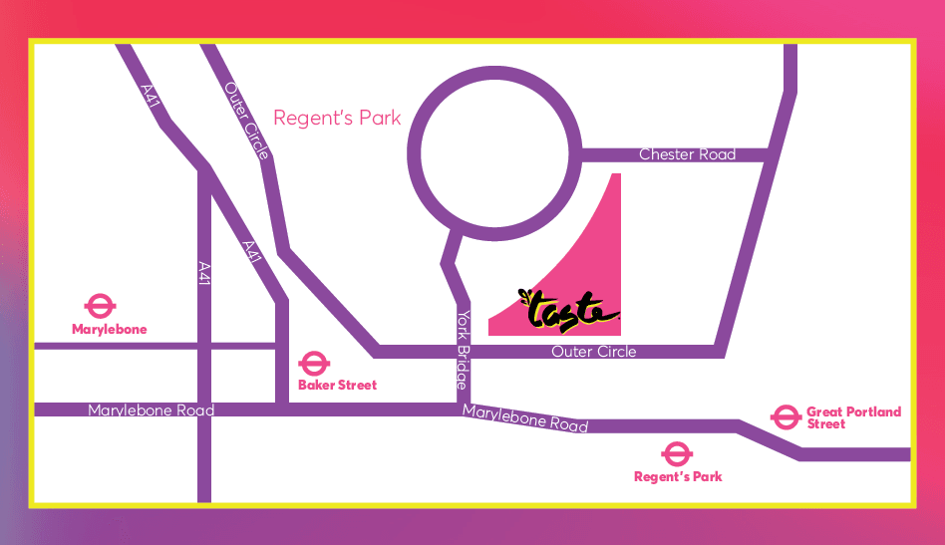

Accessible Map
Once the map for Taste of London 2025 has been released, we will have a version highlighting accessible facilities linked here. Check back soon!

Accessible Facilities
- Accessible toilets throughout the event
- Changing Places located at the West Toilet Block, on left after entry
- Large print menus – available at The Information Point or speak to individual restaurant teams.
- Priority seating – look for the Priority Seating stickers throughout the festival.
- Hearing loops – available at all our Cook School classes. Please switch your hearing aid to the T setting and connect to the available audio.
- Wheelchair ramps up to your favourite restaurants to order and collect your food easily.
- Wheelchair hire - from our Box Office on-site at Taste of London. Please note you must book this in advance by contacting our team here
- Dog spending area
- Stewards to help with any difficulties that may arise over your visit

Sound and Lighting
Taste of London can include flashing lights, flash photography and music throughout the festival.

Food and Drink
We aim to cater for as many people as possible to ensure everyone is able to enjoy delicious food during the event. Whilst participating traders at Taste of London will make every attempt to identify ingredients that may cause the most common allergic reactions, there is always a risk of cross-contamination and those with allergies should be mindful of this.
Please have a chat with any of our restaurants and artisan producers when you drop by about the ingredients in their dishes. They will always be happy to help with any questions (and convince you into another dish or two).

Assistance Dogs
Taste of London is committed to making sure the event is as inclusive and accessible to all and we understand that some customers will rely on an assistance dog to attend our events. Taste of London can be crowded and at times loud, creating an unpleasant environment for animals. For these reasons, we do not permit our customers to bring non assistance animals with them.
Taste of London reserves the right to turn away dogs at the gate who do not comply with Assistance Dogs UK guidelines surrounding assistance dogs.
In order to ensure the smoothest entry possible, we would ask customers to contact our customer service team so that they can help facilitate your entry at the festival and provided necessary information regarding the venue.
Please contact our team under Accessibility Information here: https://help.london.tastefestivals.com/hc/en-gb/requests/new

Orientation Visits
If you require to visit before deciding on attending to see if the event is suitable, please contact a member of our team regarding an orientation visit and they will be able to assist.

Distances On-Site
It is around 200m from the queue entry point by the Broad Walk in The Regent’s Park to the event entrance.
The festival takes place on Marylebone Green inside The Regent’s Park, in a triangular space of around 250m x 250m.
Walking distances around the event will depend on which stands/restaurants you wish to visit, however any key paths around the event will have trackway surfacing and there are seating options around the site. If you would like to hire a wheelchair please contact our customer service team in advance of the event, or visit us at the Info Point on-site to enquire.

